**What is Database?**

The database is Software used to Store information about Our Website/Customers/Products

**Why do we need a Database?**

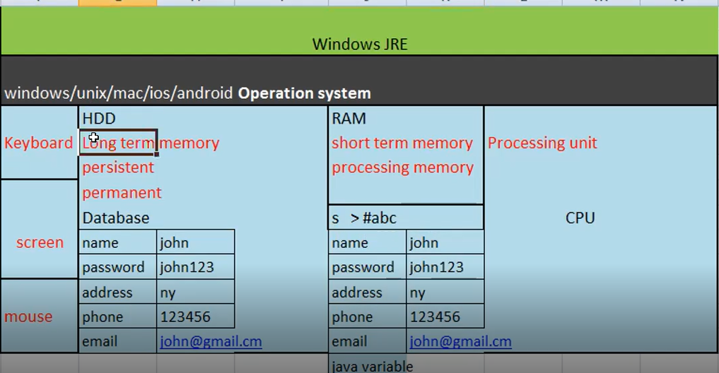

**What is Work Bench?**

IDE for Executing the DB Query

**How to Establish Connect to MySQL Server?**

**SQL Query:**

**Creating Data Base:**

Create database Shopping_Cart; (Only One time we have to Execute this Query)

**Selecting Database for operations:**

Use database name (Ex- Use Shopping_Cart)

**Creating Table:**

Create table Users (

UserId varchar (64),

password varchar (64),

emailID varchar (64),

mobile int

);

**MySQL Data Type: Different Data Types Used in SQL**

* Varchar = String like values 🡪 John123 or iPhone:

Varying Characters (Saves Memory but Slow)

* Char = Sting like values 🡪 John, iPhone

Fixed Characters (Fast but Consumes lot of Memory)

* Date

07/21/2022 (Important for tracking Orders etc..)

* Timestamp

07/21/2022 05:05:23 (Includes date as well time details)

* Int

123456 (Used to store whole Numbers)

* Float

123.5677 ( Used to store Fraction Numbers)

Example:

Create table Orders (

Odrderid int,

Userid varchar (10),

Product varchar (20),

Quantity datatype?,

Price datatype?

)

**Modify the Table Created:**

* Adding new Column into table
* Deleting Existing Column from table

Add Query:

alter table orders add address varchar (120);

Delete Query:

alter table orders drop column address;

**Truncate Table:**

This operation will delete only the Records from the respective table

Insert into users (userId,password,emailId,mobile) values(‘John’, ‘John!1’ , ‘test1@gmail.com’ , 123456);

Insert into users (userId,password,emailId,mobile) values(‘Andrew1’, ‘and1!’ , ‘test2@gmail.com’ , 1234567);

Select * from users;

Truncate table users;

**Drop Table:**

This operation will delete the Records as well as entire Table from the Database

Insert into users (userId,password,emailId,mobile) values(‘John’, ‘John!1’ , ‘test1@gmail.com’ , 123456);

Insert into users (userId,password,emailId,mobile) values(‘Andrew1’, ‘and1!’ , ‘test2@gmail.com’ , 1234567);

Select * from users;

Drop table users;

*Previous Day:*

1. What is Database?
2. Importance of Database?
3. Creating Database
4. Creating Table
5. Adding Column to Existing DB Table
6. Deleting the Column from Existing DB Table
7. Truncate Operations
8. Drop Table Operations

***All These Operations are called as DDL - Data Definition Languages***

***All DDL operations are taken care of by DBA – Database Administrator***

*DML - Data Manipulation Language is used to Modify or Manipulate the DB Table Records:*

**DML Operations:**

*CRUD – Create, Read, Update, Delete (Operations)*

**SQL Commands**: Structured Query Language

**SQL is a language used for executing DB operations**

* Create – We use the Insert command
* Read – We use Select Command
* Update – We use Update Command (Very Critical Operation. Always followed by Where Conditions)
* Delete – We use Delete Command (Very Critical Operation. Always followed by Where Conditions)

**Insert, Update & Delete Operations Enabling:**

SET SQL_SAFE_UPDATES = 0;

This Query is for enabling the Insert & Update operations Manually when some DB is blocked

**Select Query Syntax:**

* Select userid from login
* Select userid, password, emailid from login
* Select * from login
* Select userid, password, emailid from login where userid =’john’;

**Insert Query Syntax Explanation:**

* Insert into login (userid, password, emailid, phonenumber) values (‘Jane1’, ‘Jane1!’, ‘test@gmail.com’, 1234567890)
* Select * from login 🡪 Verify the data inserted
* Insert into login (userid) values(‘Jane2’) 🡪 it will insert value into 1 Column and the remaining Columns filled with Null values
* Insert into login (userid, password, emailid, phonenumber) values (‘Jane1’, ‘Jane1!’, ‘test@gmail.com’) 🡪 **Wrong query**
* Insert into login (userid, password, emailid) values (‘Jane1’, ‘Jane1!’, ‘test@gmail.com’, 1234567890) 🡪 **Wrong Query**

**Update Query Syntax Explanation:**

*Writing a condition in the Update query is very important and we should not forget*

* Update login set password =’ abc’ where userid =’jhon’;
* Select * from login where userid = ‘jhon’;
* Update login set password = ‘abc’; -🡪 **Wrong Query. It will update All Users Password into ‘abc’**

**DR – Disaster Recovery Process**

This process is used to restored DB data by DB Administrators when data last due some Technical or Natural Calamities

**Delete Query Explanation:**

**Writing a condition in Update query is very important and we should not forget**

* Delete from login where userid = ‘John’;
* Delete from login where password = ‘ abc’ 🡪 We can use any condition for deleting
* Delete from login 🡪 Wrong. It will delete all the records from the Table

**Where Conditions Explanation:**

**AND:** Example - User Login into Shopping Application

* Select * from login where userid =’John’ and password = ‘ abc’ ; 🡪 both conditions should pass
* Select * from login where userid =’John’ and password = ‘ abc’ and emaild = ‘test@gmail.com’; 🡪 All the conditions should pass
* Select * form login where userid =’John’ and Password = ‘ xyz’ ; 🡪 Second Condition failed. No results

**OR**: Example – Users Forgot Password or Retrieve Password Functionality

* Select * from login where userid =’John’ or password = ‘ abc’ ; 🡪 1 conditions should pass

(1 Record Displayed)

* Select * from login where userid =’Mike’ or password = ‘ abc’ ; 🡪2 conditions passed

(2 Records Displayed)

* Select * from login where userid =’xxx’ or password = ‘ yyy’ ; 🡪2 conditions failed

(0 Records Displayed)

**IN/Not IN:** Example – Users are trying to retrieve data from Different States

***Checking the Multiple values on the same Columns***

* Select * from login where userid = ‘john’ or userid = ‘mike’ or userid = ‘test’;
* Select * form login where userid in (‘john’ , ‘mike’ , ‘test’);
* Select * form login where state in (‘NY’ , ‘NJ’, ‘PA’ , ‘MI’); **US East Regions**
* Select * form login where state not in (‘NY’ , ‘NJ’, ‘PA’ , ‘MI’); **US East Regions**

(It will display 1 Record which is having State Value as FL)

**LIKE:** Example – Retrieving Userid based on the Partial data

% = any Character in Partial match (0 or more many Char)

Userid = 123Andy123

Userid = 123John123

Select * from login where userid like ‘123Andy%’; 🡪 1 Record will get display

Select * from login where userid like ‘%123’; 🡪 2 Records will get display

Select * from login where userid like ‘123%’ 🡪 2 Records will get display

**DISTINCT: Example -** Retrieving the People count form All the states

Column: State – ‘NY’ , ‘NJ’, ‘FL’ , ‘MN’, ‘NY’, ‘NJ’

* Select distinct state from login 🡪 4 Records will get displayed

**COUNT: Example** – Checking the count of Users in the Shopping Applications

* Select count (Userid) from Login
* Select count (Userid) form Login where state = ‘ NY’ ;

**ORDER BY:**

1. Select * from login order by state 🡪 Alphabetical Order /Ascending Order (Numbers)
2. Select * from login order by state desc 🡪 Descending Order
3. Select * from login order by userid , state 🡪 Multiple Column

**GROUP BY: Example - Used by higher management for Business Establishment**

* Select state, count(state) from login group by state

**DR – Disaster Recovery Process**

This process is used to restored DB data by DB Administrators when data last due some Technical or Natural Calamities

* Graphical user interface, application, table, Excel

  Description automatically generated